NOTE: Your student planning must be complete before your appointment. Students unprepared may be asked to reschedule. Please come at least 30 minutes early to your appointment if you need additional assistance.

1. Go to wtamu.edu, click on the **BUFF CONNECT** icon. It can be found at the top of the home page.



1. Log in with your username and password, select the **BUFF ADVISOR** icon located on the top right corner of the page.

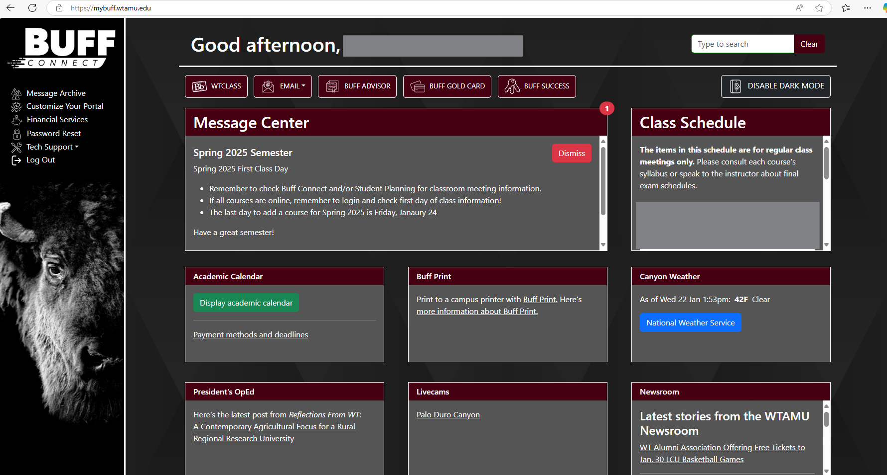

1. The Buff Adviser menu has 9 sections. On the left side of the screen please select **STUDENT PLANNING**.

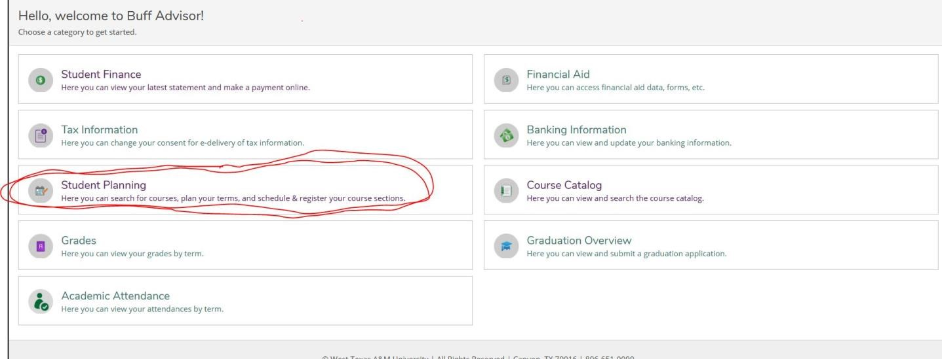

1. Student planning will open as a new window. You will have two option to select from “View Your Progress” and “Plan Your Degree & Register for Classes”. Select “**Plan your Degree & Register for Classes,**” your schedule for the current semester will be displayed.

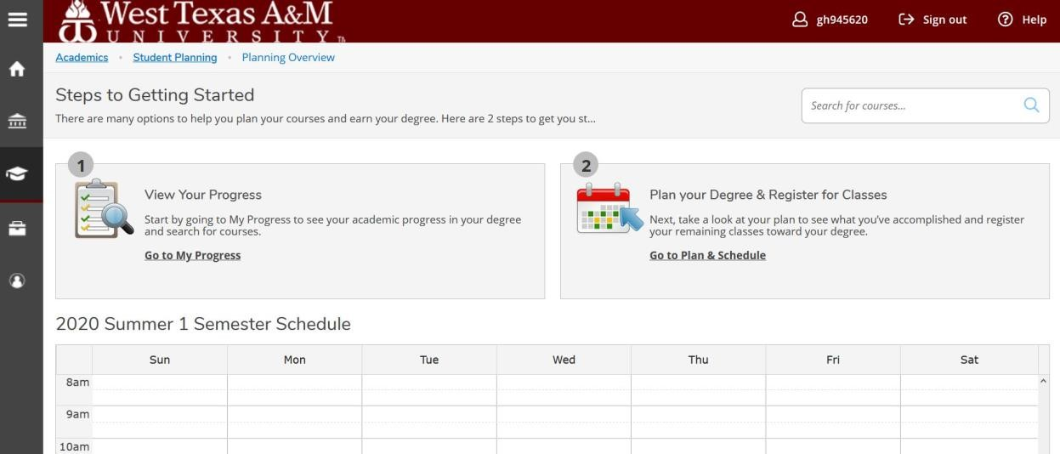

1. Once on the calendar view, make sure you use the arrows to scroll over to the semester you are wanting to add the courses to.
2. Use your **DEGREE CHECKLIST** along with the “my progress” tab to view the classes you have completed and to select potential classes that pertain to your major for upcoming semester(s).

1. To select a course, type the course abbreviation and number in the search bar located near the top right side of the screen. An example of a class would be “MATH 1314. Courses may be entered various ways which may result in more or fewer results. “MATH1314” will result in the most concise search. MATH and MATH 1314 will produce broader search results.

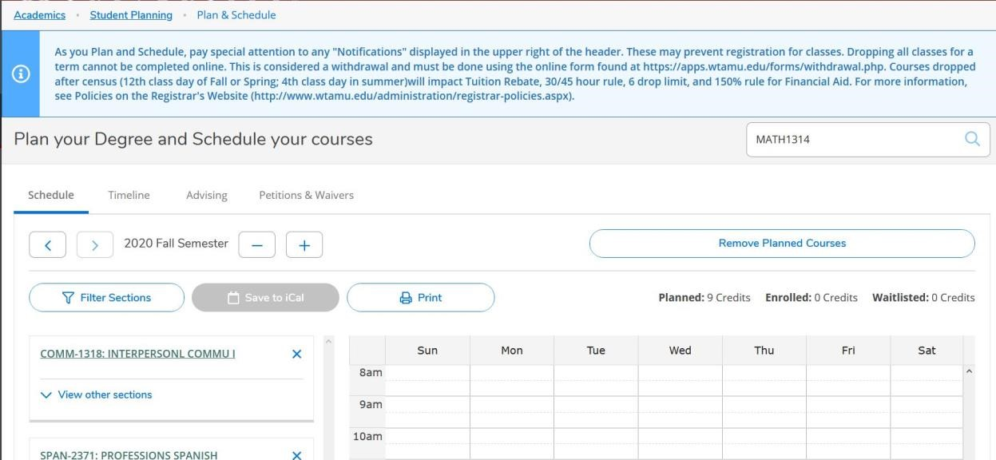

1. The course name, number, and description will appear. You will see a button to the right of the course name labeled **ADD COURSE TO PLAN**, select this option.

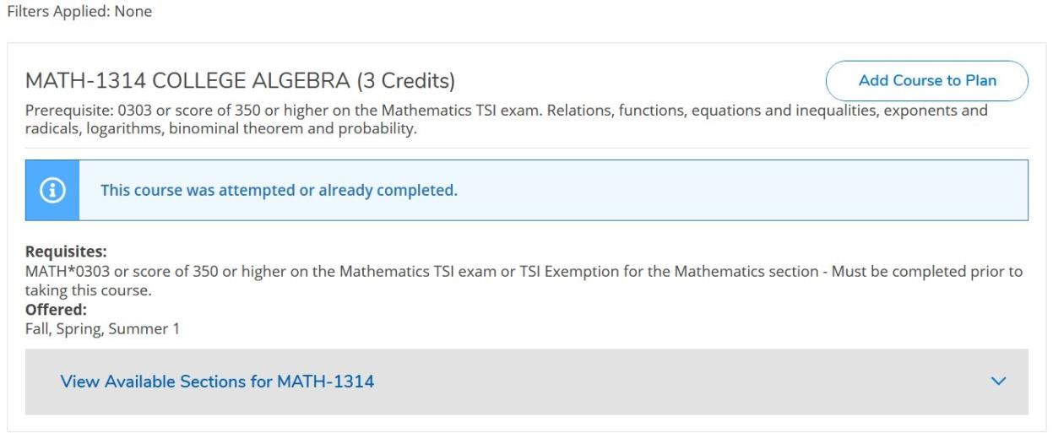

1. Pop-up screen will allow you to select the term you want to add the course to. Semester can be selected from the drop down menu located at the bottom of the screen that says **SELECT A TERM**. Pick the term, then select **ADD COURSE TO PLAN** on the bottom right side of the screen.

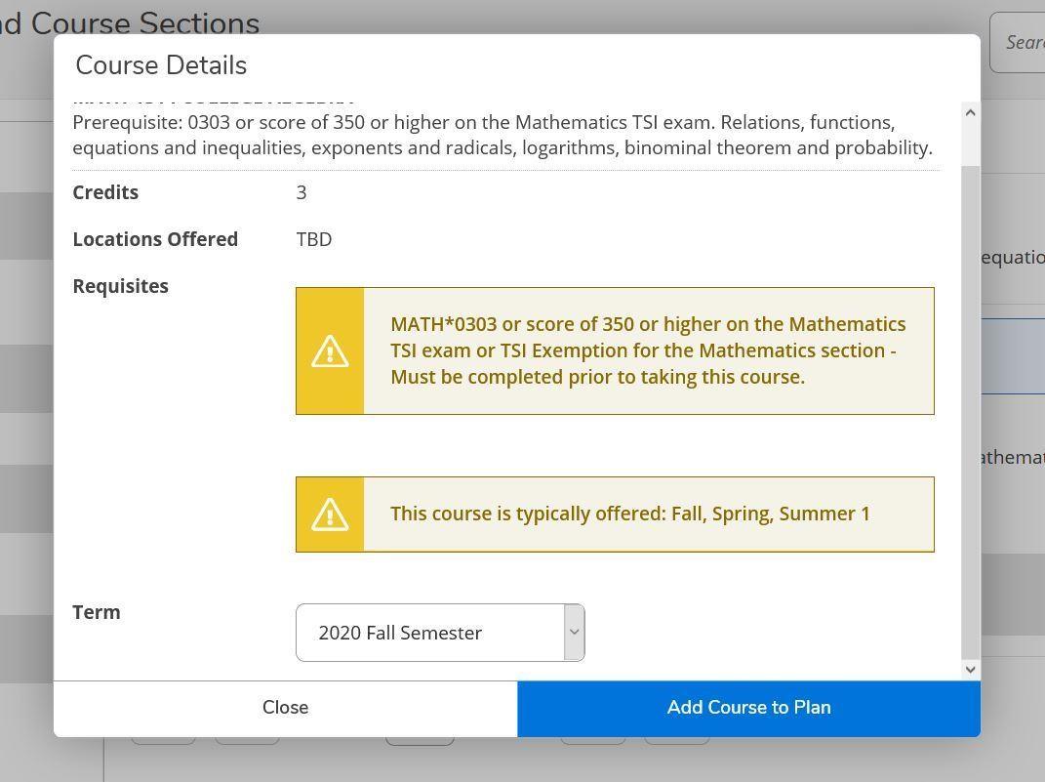

1. Repeat steps 5-8 for each course you want to add to the upcoming semester.

1. **SECTIONS WILL NOT ALWAYS BE AVAILABLE WHEN GREENIGHTING START.** However, once they are available and once you are ready to select sections, you will need to go back to the original calendar view. Once here, you will select **VIEW OTHER SECTIONS** for the course you wish to see sections (days/times) for. Select the sections you want and add it to your schedule by clicking **ADD SECTION**.

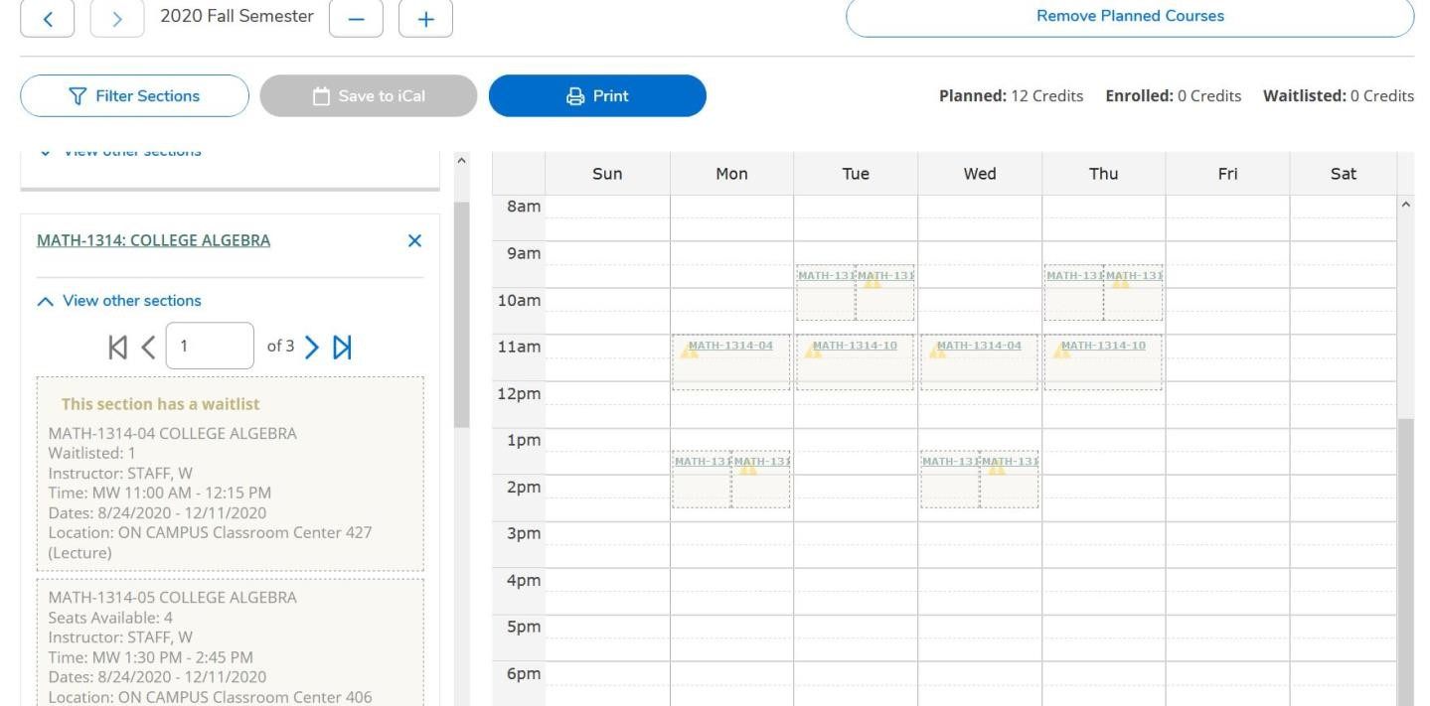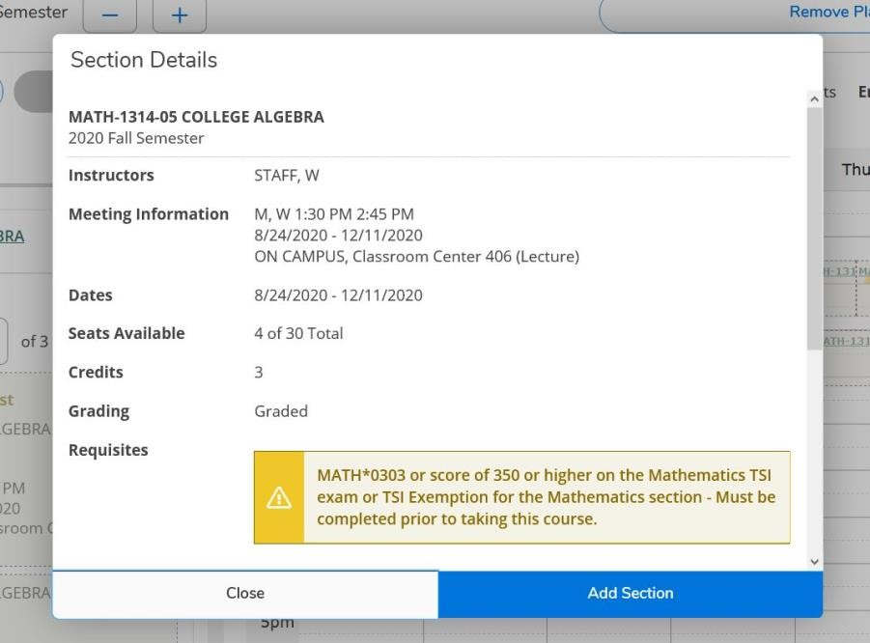

1. Remember you need at least 4 courses that pertain to your major to be able to visit with an academic adviser.
2. PLEASE BE SURE TO TAKE A SCREENSHOT OR A PICTURE OF YOUR PLANNED COURSES. You can find this list on the calendar view for the term you are enrolling in. IF YOU NEED HELP, please stop by advising at least 30 minutes before your appointment.